Networking Task
- There are three sections in this question please find the answers each part :
- To get the ip of a particular domain we can use ping , nslookup commands as per this ip of guvi.in is 104.26.5.88
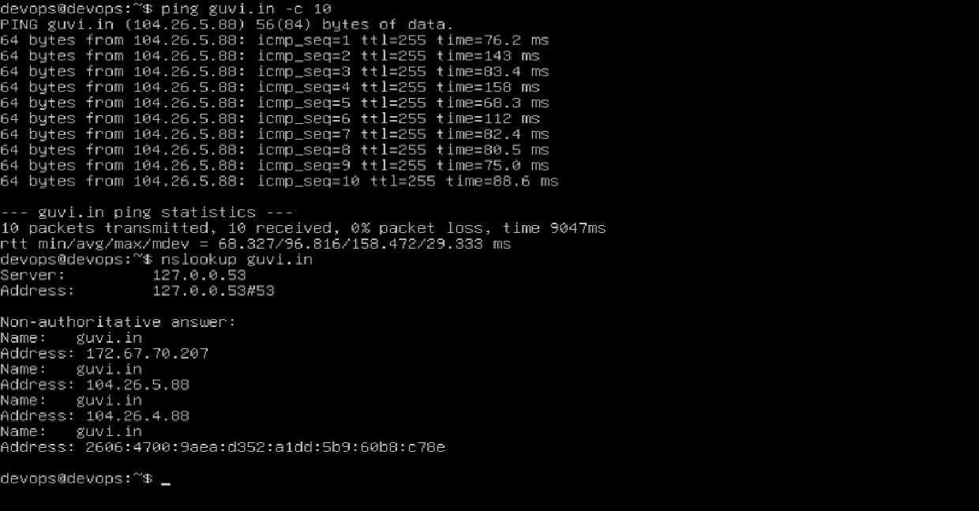
- To find the memory/CPU usage in your system use free -h also top
Free -h
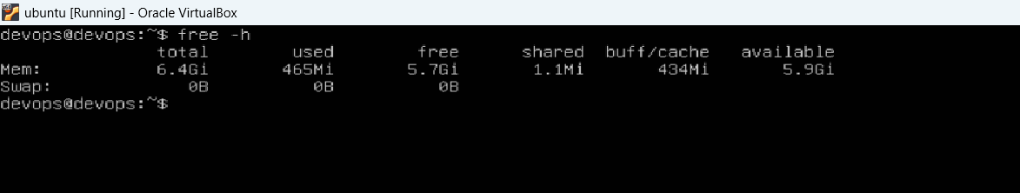
Used Top command for CPU and memory information in real-time
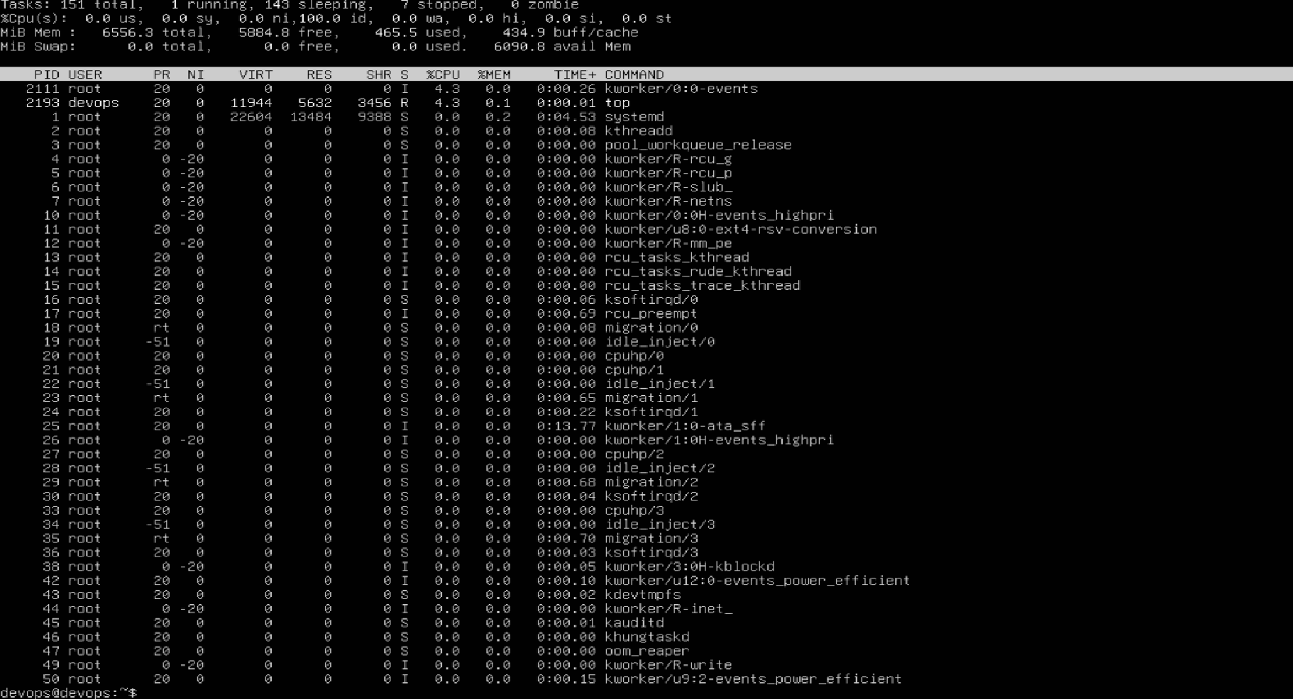
- To test the connectivity between 2 nodes we can use ping
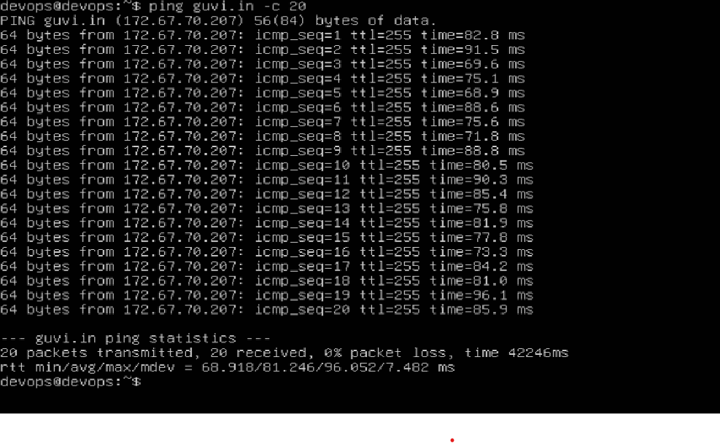
- The port 9000 is not opened when we use a telnet with port 9000 we cannot find a connection of a particular port .
